Gravity - 03
CLASS 09 - SCIENCE

 | Section A
1 | Match the following Column A with Column B: 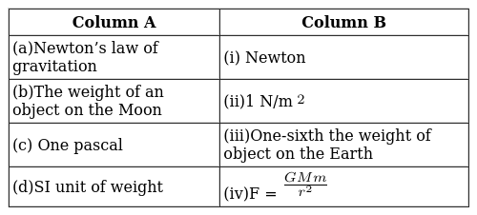 | [2]
2 | Match the following Column A with Column B: 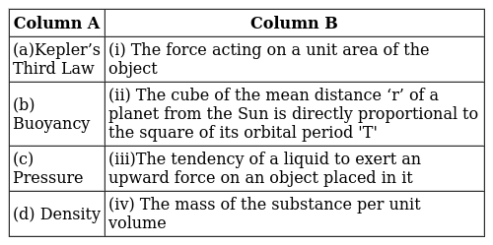 | [2]
3 | Match the following Column A with Column B: 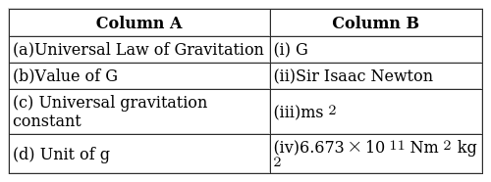 | [2]
4 | Match the following Column A with Column B: 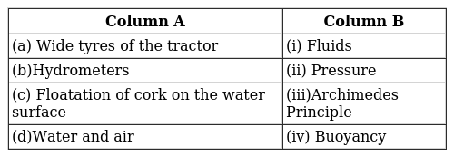 | [2]
5 | Match the following Column A with Column B: 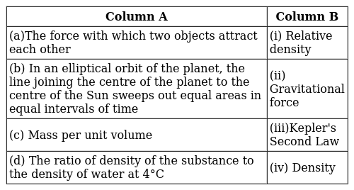 | [2]
6 | Match the following Column A with Column B: 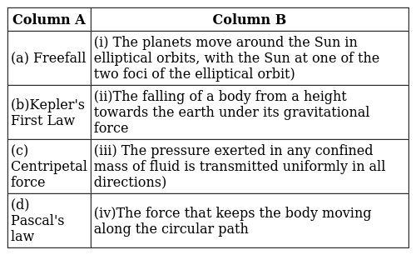 | [2]
7 | Match the following Column A with Column B: 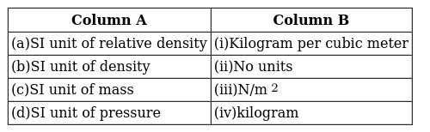 | [2]
8 | Match the following Column A with Column B: 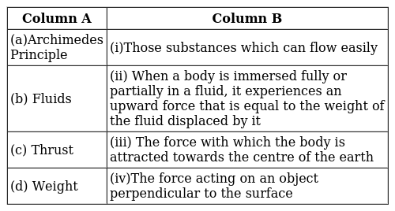 | [2]
 | Section B
9 | What do we call the gravitational force between the earth and an object? | [1]
10 | You find your mass to be 42 kg on a weighing machine. Is your mass more or less than 42 kg? | [1]
11 | Which force causes things to fall towards the earth? | [1]
12 | What do you understand by the gravitational force of earth and weight? | [1]
13 | What is the acceleration of free fall? | [1]
14 | Mass of an object is 10 kg. What is its weight on the earth? | [1]
15 | What do you mean by free fall? | [1]
16 | State Archimedes Principle. | [1]
17 | Explain the universal law of gravitation. | [1]
18 | The astronauts in space feel weightless. Why? | [1]
19 | If the moon attracts the earth, why does the earth not move towards the moon? | [1]
20 | Give reason - stone falls towards the earth but earth do not rise towards the stone. | [1]
21 | The earth is acted upon by gravitation of the sun, even thoughit does not fall into it. Why? | [1]
22 | A man’s weight when taken at the poles is 600N. Will is weight remain the same when measured at the equator? Will there be an increase or decrease is his weight? Explain. | [1]
23 | Suppose gravity of the earth suddenly becomes zero, then which direction will the moon begin to move, if no other celestial body affects it? | [1]
24 | What do you mean by buoyancy? | [1]
25 | Who found out the value of gravitational constant (G)? | [1]
26 | In what direction does the buoyant force on an object immersed in a liquid act? | [1]
27 | Two objects of masses m$​_{1}$ and m $​_{2}$ are dropped in vacuum from a height above the surface of the earth (m $​_{1}$ is greater than m $​_{2}$ ). Which one will reach the ground first and why? | [1]
28 | What is weightlessness? | [1]
29 | An object weighs 10 N when measured on the surface of the earth. What would be its weight when measured on the surface of the moon? | [1]
30 | The weight of a man on the earth is 100 kg. Does this weight on the moon increase or decrease? | [1]
31 | Two objects kept in a room do not move towards each other as per the universal law of gravitation. Why? | [1]
32 | The radius of the earth is about 6370Km. An object of mass 30Kg is taken to a height of 230Km above the surface of the earth.  - What is the mass of the body?  - What is the acceleration to gravity at this height?  - What is the weight of the body at this height? | [3]
33 | Amit buys few grams of gold at the poles as per the instruction of one of his friends. He hands over the same when he meets him at the equator. Will the friend agree with the weight of gold bought? If not, why? | [3]
34 | What happens to the magnitude of the force of gravitation between two objects, if  - distance between the objects is tripled?  - mass of both objects is doubled?  - mass of both objects as well as the distance between them is doubled? | [3]
35 | A body weighs 25 kg on the surface of the earth. If the mass of the earth is 6$×$ 10 $​^{24}$ kg, then the radius of the earth is 6.4 $×$ 10 $​^{6}$ m and the gravitational constant 6.67 $×$ 10 $​^{−11}$ N - m $​^{2}$ /kg $​^{2}$ . Calculate  - the mutual force of attraction between the body and the earth.  - the acceleration produced in the body.  - the acceleration produced in the earth. | [3]
36 | A ball is dropped from the jumping board of a swimming pool, which is at a height of 20 m. A second ball is thrown from the same board after one second with initial velocity u. If both the balls hit the water together, calculate the initial velocity of second ball. Do they hit the ground at the same time? (Take g = 10 ms$​^{−2}$ ) | [3]
37 | The mass of the earth is 6$×$ 10 $​^{24}$ kg and that of the moon is 7.4 $×$ 10 $​^{22}$ kg. If the distance between the earth and the moon is 3.84 $×$ 10 $​^{5}$ km, calculate the force exerted by the earth on the moon. (Take G = 6.7 $×$ 10 $​^{−11}$ Nm $​^{2}$ kg $​^{−2}$ ) | [3]
38 | A ball is thrown vertically upwards. The speed of the ball was 10m/s when it had reached one half of its maximum height.  - How high does the ball rise?Take g= 10ms$​^{2}$  - Find the velocity and acceleration 1s after it is thrown. | [3]
39 | - Seema buys few grains of gold at the poles as per the instruction of one of her friends. She hands over the same when she meets her at the equator. Will the friend agree with theweight of gold bought? Ifno, why?  - If the moon attracts the earth, then why does the earth not move towards the moon? | [3]
40 | Shashank placed an iron cuboid of dimensions 4 cm$×$ 7 cm $×$ 10 cm on a tray containing fine sand. He placed the cuboid in such a way that it was made to lie on the sand with its faces of dimensions  - 4 cm$×$ 7 cm,  - 7cm$×$ 10cm,  - 4 cm$×$ 10 cm. If the density of iron is nearly 8 g cm $​^{−3}$ and g =10 ms $​^{−2}$ , find the minimum and maximum pressure as calculated by Shashank.  . | [3]
41 | - According to universal law of gravitation, every object in this universe attracts every other object. Explain, why then a table and a chair lying in the same room do not collide with each other?  - An object is thrown vertically upwards to a height of 12 m. Calculate its  - velocity with which it was thrown upwards.  - time taken by the object to reach a height of 12 m. | [3]
42 | A coconut is hanging on a tree at a height of 15 m from the ground. A boy launches a projectile vertically upward with a velocity of 20 ms$​^{−1}$ . After what time, the projectile will pass by the coconut. Explain the two answers that you get in this problem. (Take g = 10 ms $​^{−2}$ ) | [3]
43 | A ball thrown up vertically returns to the thrower after 6s.Find  - the velocity with which it was thrown up.  - the maximum height it reaches and  - its position after 4s. | [3]
44 | A cylindrical block of wood of height 4.2 m and mass 100 Kg floats vertically in water. The relative density of wood is 0.8 m/v) What height of the block will be seen above the water? ) If block of lead of mass 10 kg is placed, what height of the block will be seen above water? | [3]
45 | Two objects of masses m$​_{1}$ and m $​_{2}$ having the same size are dropped simultaneously from heights h $​_{1}$ and h $​_{2}$ respectively. Find out the ratio of time they would take in reaching the ground. Will this ratio remain the same if  - one of the objects is hollow and the other one is solid; and  - both of them are hollow, size remaining the same in each case? Give reasons. | [3]
46 | In an experiment to determine the relative density of cork, the following observations were made. Weight of sinker in water W$​_{1}$ = 200 gf Weight of cork in air and sinker in water W $​_{2}$ = 220 gf Weight of cork and sinker both in water W $​_{3}$ = 140 gf Calculate: i) the upthrust on cork due to water, ii) the volume of cork and iii) the relative density of cork. | [3]
47 | The mass of a planet Jupiter is 1.9$×$ 10 $​^{27}$ kgand that of the sun is 1.99 $×$ 10 $​^{30}$ kg. The mean distance of the sun from Jupiter is7.8 $×$ 10 $​^{11}$ . Calculate the gravitational force which the sun exerts on Jupiter. | [3]
48 | Calculate the force of gravitation between the earth and the Sun, given that the mass of the earth = 6$×$ 10 $​^{24}$ kg and of the Sun = 2 $×$ 10 $​^{30}$ kg. The average distance between the two is 1.5 $×$ 10 $​^{11}$ m. | [3]
49 | A ball thrown up vertically returns to the tower after 6 s. Find  - the velocity of the ball with which it was thrown up,  - the maximum height it reaches, and  - the position of the ball after 4 s. | [3]
50 | The radius of earth is 6370 Km and of mars is 3400 Km. If an object weighs 200N or earth, what will be its weight on mars. The mass of mars is 0.11 that of earth. | [3]
51 | What is the up thrust experienced by a balloon of volume 120m$​^{3}$ filled with hydrogen.( Given.The density of air is 1.140 Kg/m $​^{3}$ and density of hydrogen is 0.081Kg/m $​^{3}$ ) at room temperature. What is the maximum weight this balloon can lift? | [3]
52 | The mass of the mars is 6.39$×$ 10 $​^{23}$ kg and that of the jupiter is 1.89 $×$ 10 $​^{27}$ kg. If the distance between mars and jupiter is 749 $×$ 10 $​^{3}$ m. Calculate the force exerted by the jupiter on the mars. (G = 6.7 $×$ 10 $​^{−11}$ Nm $​^{2}$ kg $​^{−2}$ ) | [3]
53 | A boy on a cliff 49m high, drops a stone to the ground.One second later, he throws another stone vertically downwards. The two stones hit the ground at the same time. What was the velocity with which the second stone was thrown? | [3]
54 | A block of wood tied to the bottom of water tank as shown. The wooden block exerts tension, on the wire tied to it. The dimension of the block are 20 cm × 20 cm × 40 cm. 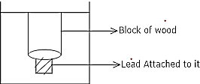  The density of the wood is 600 Kg/m $​^{3}$ . What is the tension in the wire? | [3]
55 | A stone is dropped from a height of 50m on earth. At the same time, another stone is thrown vertically upwards from the ground with a velocity up wards from the ground with a velocity of 50m/s. At what height from the ground will the two stones meet (g = - 10 m/s$​^{2}$ ) | [3]
56 | What is the up thrust experienced by a cube of edge - length 5 cm made of iron when completely immersed in ethanol of density 0.8 g/cm$​^{3}$ | [3]
57 | A car falls off a ledge and drops to the ground in 0.5 s. Let g = 10 ms$​^{−2}$ (for simplifying the calculations).  - What is its speed on striking the ground?  - What is its average speed during the 0.5 s?  - How high is the ledge from the ground? | [5]
58 | Define acceleration due to gravity. Derive an expression for acceleration due to gravity in terms of mass of the earth (M) and universal gravitational constant (G). | [5]
59 | - Suppose the mass of the earth somehow increases by 10% without any change in its size. What would happen to your weight?  - Suppose the radius of the earth becomes twice of its present radius without any change in its mass.What will happen to your weight? | [5]
60 | A block of wood is kept on a tabletop. The mass of the wooden block is 5 kg and its dimensions are 40 cm$×$ 20 cm $×$ 10 cm. Find the pressure exerted by the wooden block on the table top if it is made to lie on the table top with its sides of dimensions 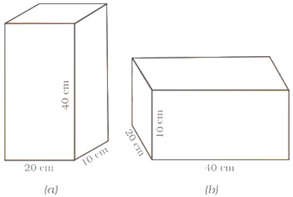  - 20 cm$×$ 10 cm and  - 40 cm$×$ 20 cm. | [5]
61 | A stone is dropped from a 100 m high tower. How long does it take to fall?  - the first 50 m and  - the second 50 m. | [5]
62 | - A steel needle sinks in water but a steel ship floats. Explain, how?  - Why do you prefer a broad and thick handle of your suitcase? | [5]
63 | What are the differences between the mass of the object and its weight? | [5]
64 | From a cliff of 49 m high, a man drops a stone. One second later, he throws another stone. They both hit the ground at the same time. Find out the speed with which he threw the second stone. | [5]
65 | - A person weighs 110.84 N on the moon, whose acceleration due to gravity is 1/6 of that the earth. If the value of g on the earth is 9.8 m/s$​^{2}$ , then calculate  - g on the moon  - mass of person on the moon  - weight of person on the earth  - How does the value of g on the earth is related to the mass of the earth and its radius? Derive it. | [5]
66 | A stone is allowed to fall from the top of a tower 100 m high and at the same time another stone is projected vertically upwards from the ground with a velocity of 25 ms$​^{−1}$ . Calculate when and where the two stones will meet. | [5]
67 | - Write the formula to find the magnitude of the gravitational force between the earth and an object on the earth’s surface.  - Derive how does the value of gravitational force F between two objects change when  - distance between them is reduced to half and  - mass of an object is increased four times. | [5]
68 | - Prove that, if the earth attracts two bodies placed at the same distance from the centre of the earth with equal force, then their masses will be the same.  - Mathematically express the acceleration due to gravity in terms of mass of the earth and radius of the earth.  - Why is G called a universal constant? | [5]
69 | - A cube of side 5 cm is immersed in water and then in saturated salt solution. In which case, will it experience a greater buoyant force? If each side of the cube is reduced to 4 cm and then immersed in water, what will be the effect on the buoyant force experienced by the cube as compared to the first case for water. Give the reason for each case.  - A ball weight 4 kg of density 4000 kg m$​^{−3}$ is completely immersed in water of density 10 $​^{3}$ kg m $​^{−3.}$ Find the force of buoyancy on it. (Given g = 10 ms $​^{−2}$ .) | [5]
70 | Derive an expression for the force of attraction between two bodies and then define gravitational constant. | [5]
71 | A stone is dropped from the edge of a roof.  - How long does it take to fall 4.9 m?  - How fast does it move at the end of that fall?  - How fast does it move at the end of 7.9 m?  - What is its acceleration after 1s and after 2 s? | [5]
72 | Show that the weight of an object on the moon is$\frac{1}{6}$ th of its weight on the earth. Given, the mass of the earth M $​_{e}$ = 6×10 $​^{24}$ kg , mass of the moon, M $​_{m}$ =7⋅4×10 $​^{22}$ kg , The radius of the earth, R $​_{e}$ = 6400 km and radius of the moon, R $​_{m}$ = 1740 km. | [5]
73 | What is the magnitude of the gravitational force between the earth and a 1 kg object on its surface? (Mass of the earth is$6×{10}^{24}$ kg and radius of the earth is $6.4×{10}^{6}$ m). | [5]
74 | - At some moment, two giant planets Jupiter and Saturn of the solar system are in the same line as seen from the earth. Find the total gravitational force due to them on a person of mass 50 kg on the earth. Could the force due to the planets be important?Mass of the Jupiter = 2 $×$ 10 $​^{27}$ kg Mass of the Saturn = 6 $×$ 10 $​^{26}$ kg The distance of Jupiter from the earth = 6.3 $×$ 10 $​^{11}$ m The distance of Saturn from the earth = 1.28 $×$ 10 $​^{12}$ m  - A bag of sugar weighs ’w’ at a certain place on the equator. If this bag is taken to Antarctica, then will it weigh the same or more or less. Give a reason for your answer. | [5]
75 | The weight of any person on the moon is about 1/6 times that on the earth. He can lift a mass of 15 kg on the earth. What will be the maximum mass, which can be lifted by the same force applied by the person on the moon? | [5]

